SELECT DISTINCT city, state, zip

FROM CUSTOMER

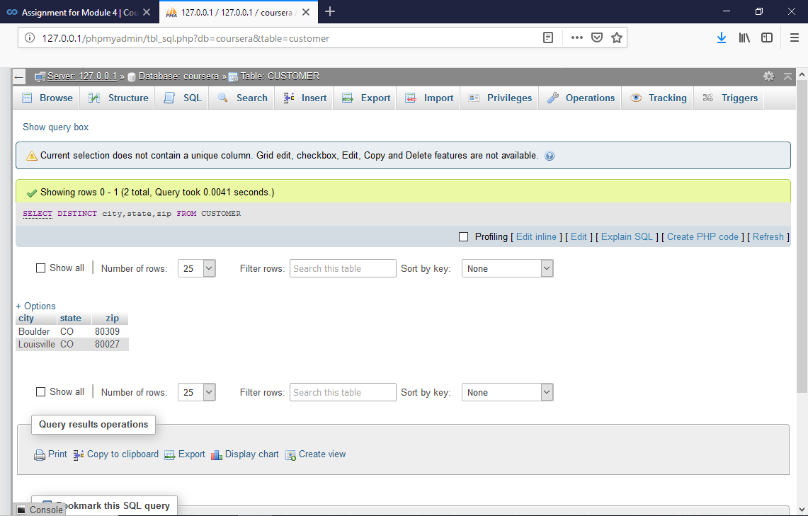

JDFJDFDJFKDFJKDF